**Background**

I am going to create an open world RPG game with a real time combat, an inventory system, different weapon classes. The Graphics will be very simple polygonal models to accentuate the simple nature of the game.

I will have a stat sheet for various actions that the player has taken which will be saved to a text file. The player will have to log in to the game, so I will store the log in details with a database and will also show the player’s scores online.

**Industry research**

The gaming industry is one that has come to prominence for its popularity with newer generations. With some estimating that the industry is worth $140 billion or £104 billion [1]. It has now become a lucrative market for people to design games.

RPG games in particular have very high unit sales like Minecraft (154 million units [2]), Skyrim (30 million units [3]), and The Witcher 3 (33 million units [4])

These games were made with the backing of large corporations and a big team of programmers so this high quality of game may be impossible to create on my own. However, many indie games made by individuals or small groups of people can also sell many units. For example, The Binding of Isaac (7.1 million units [5]), Rocket League (10.5 million units [6])

This is a medium that I feel like I can express my creativity and ability to create an enjoyable, intuitive and finished product.

**Project Scope**

The type of game that I am investigating is a First person, Open world, RPG game.

I am using the Unity Game engine as I believe that it is the best entry level software to be designing a game. It is coded in C# which is very close in syntax and logic to the only other programing language that I know: Visual Basic. Unity uses a very intuitive user interface which is simple to learn.

Unity is also very well documented with its user manual and large amount of Youtube tutorials.

**The Client/Supervisor**

The person who will be supervising my project will be computer science teacher Mr Yasin Abbas.

**Critical Path Analysis**

|  |  |  |  |  |
| --- | --- | --- | --- | --- |
| CPA | Task | Time to Complete | Type | Depends On |
| 1 | Character Movement | 1 day | Sequential |  |
| 2 | Camera Movement | 1 day | Sequential | 1 |
| 3 | Crosshair | 4 days | Parallel | 2 |
| 4 | Raycasting | 5 days | Parallel | 3 |
| 5 | Interactable Items | 5 days | Sequential | 2, 4 |
| 6 | Inventory | 1 week | Parallel | 4, 5 |
| 7 | Equipment | 3 days | Sequential | 1, 2, 5, 6 |
| 8 | Combat | 1 week | Sequential | 1, 2, 3, 4, 5, 6, 7 |
| 9 | NPCS | 2 days | Parallel | 4, 5 |
| 10 | Enemy Spawning | 3 days | Sequential | 1, 2, 7, 8 |
| 11 | Ranged Combat | 2 weeks | Sequential | 2, 3, 4, 5, 8 |
| 12 | ER Database | 2 weeks | Parallel |  |
| 13 | Log in System | 1 weeks | Sequential | 12 |
| 14 | Writing to txt. file | 1 week | Sequential | 1, 5, 8, 9, 11 |
| 15 | High score Screen | 1 week | Parallel | 12, 13, 14 |

**Prospective Users**

The potential users of my project will generally be 16 – 25 year olds as that is the average age demographic of the game that this project is most closely derived from. That being The Elder Scrolls IV: Skyrim.

They will be expected to have no computer science skills, so I will need to make the interface as intuitive and easy as possible.

**Investigation of System**

The investigative method that I have used are the Questionnaire forms to people in my target audience. This is so that I can get a better understanding on what features are most desired and how to best create the game.

I have given the questionnaire to a large amount of people, so I can receive a large variety of responses. The more people that give feedback, the more likely that I am going to find an error in my design and be able to correct it.

The people that I have chosen to take the questionnaire are people I know have an avid interest in technology or more specifically gaming.

I will also be showing my prototypes to people, so that they can give insight into the game specifically and not just a general answer to gaming in general in the questionnaire. This will give me the ability to get more nuanced feedback to be able to tweak individual systems within my game.

The existing software that is already on the market like Skyrim, Oblivion and other RPGs have inspired me to create a new system.

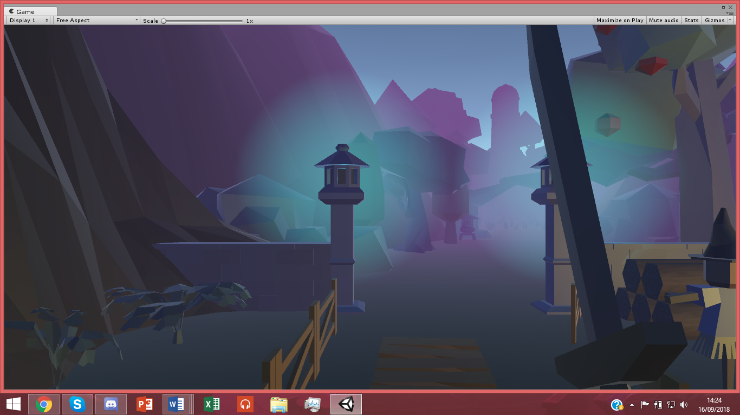My game imitates the Skyrim first person controller as it makes navigating an open world easy.

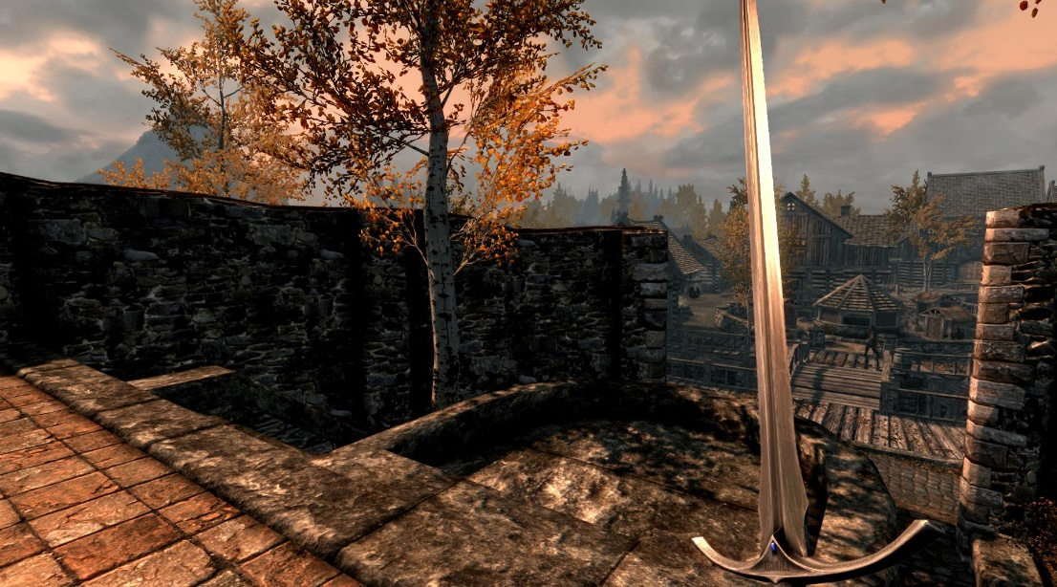

The game has a crosshair system like Skyrim, but its function better resembles Oblivion because when you hover over different interactable objects, the crosshair changes its texture to prompt the user to interact with the item.

Though many features are inspired by these games, my system will have a different slightly gameplay loop. Skyrim and Oblivion both have stealth systems that can make the game exceedingly easy, so I will not make a stealth system. This will streamline the experience to make an easier, simpler system.

Both games give the enemies a large amount of health, so combat is slow and not satisfying, so I will give enemies a lower amount of health but increase their numbers.

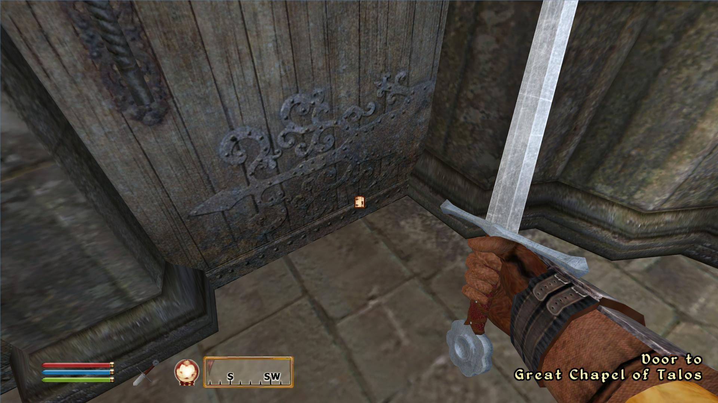In these games, the point is to be able to interact with any and all objects you can see but that would not function very well in my game as I would prefer a more robust inventory system not clogged with hundreds of items.

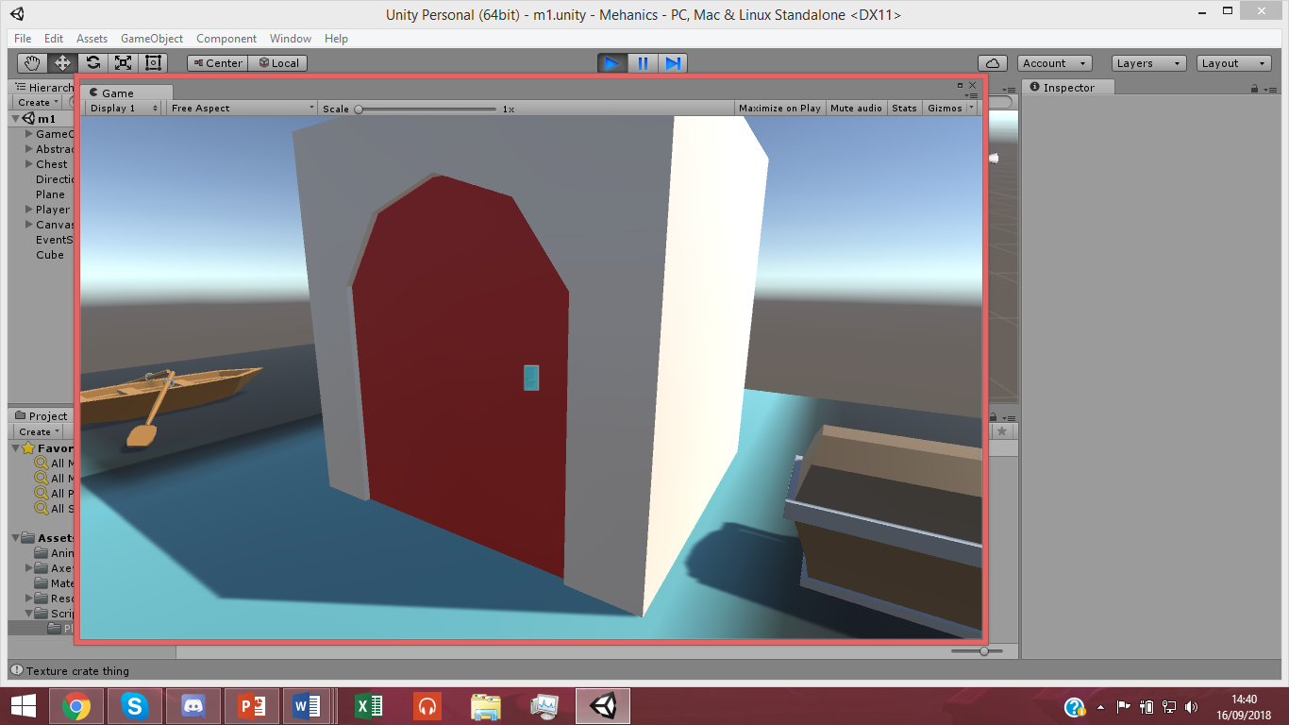In both games, they focus on exploration but limit themselves to exploring one specific biome. This increases tedium and makes exploring less exciting. In my game I have created a large number of small biomes to make the player more likely to explore.

When in combat and low on health, the player is expected to open the inventory to use a healing item. This interrupts the flow of the game and slows down the combat further. My solution to this is that there will only be one healing item and will be attached to a hotkey in game.

Opening a menu to see the world map also stops exploration and discourages the player from exploring by telling them exactly where to go. I will make the map an item that can be viewed in the hand to increase the immersion and make exploration necessary to the player.

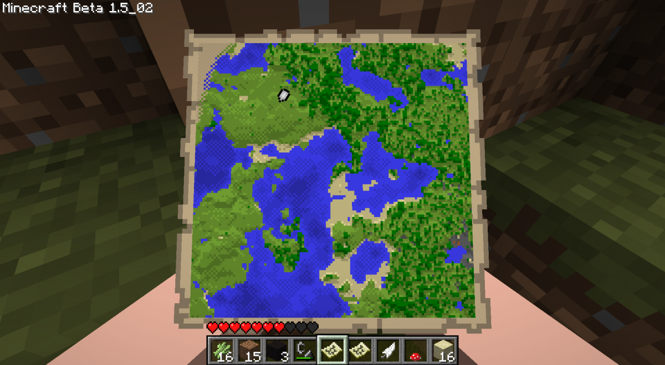The map in hand feature can be compared to Far Cry 2 or Minecraft.

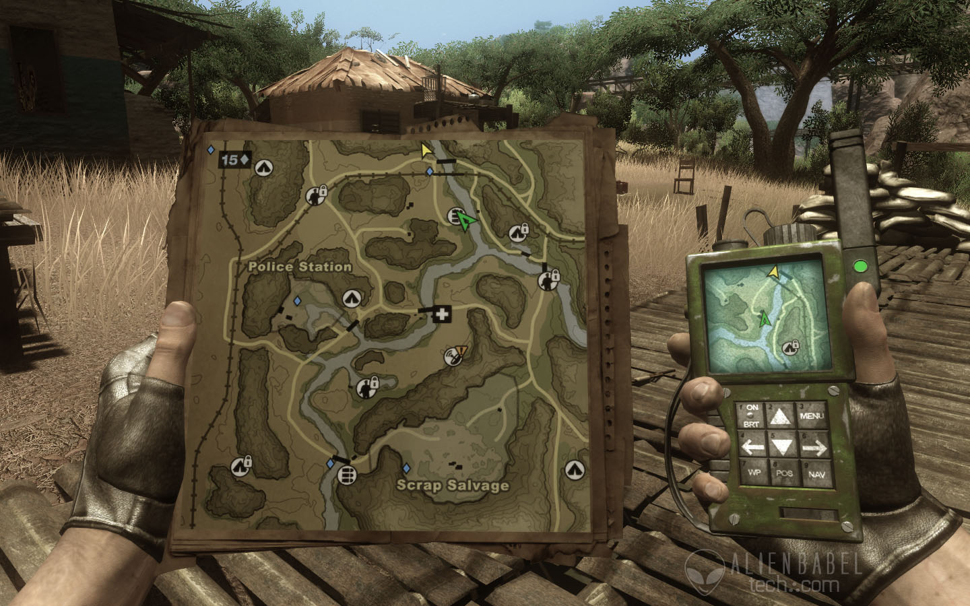

Ranged combat in these games are also unbalanced so I have made them only usable in the later stages of the game. This would make it feel like there is progression in the character.

**Questionnaire**

I gave out a questionnaire to gauge my target audience’s preferences in game and more specifically; their preferences in RPG. All of the respondents were within my target audience of 16 – 25.

The respondents were selected from people I knew had some knowledge in gaming. Though they were not expected to have any knowledge on game design or programming. 80% of the respondents said they played RPG games at least monthly so I know that my data was relevant.

The most important question I wanted to ask was what game element was most valued to the player between Combat, Story and Exploration. The results show that exploration was the most popular element of RPGs. This influenced my decision to create an open world game that featured many unique and diverse locations with distinct colour palates. This would make the exploration more exciting and less liable to induce tedium.

Similarly, Combat was deemed the least important element to an RPG. Given this feedback, I decided to make the combat systems simple and not overly complicated.

The only element left was the story but I decided a story wouldn’t be needed since it would be difficult, time consuming and ultimately not needed to create a successful game. It would be better show highlight my ability to create a vast 3D world and a competent Combat system. This is all an entry level RPG would really need.

When asked if a RPG game could function without a story, the respondents were split almost 50 – 50. With one of the respondents saying “Story is what makes a game unique. Without story it's just a concept.” I believe an entry level game and a proof of concept for a larger game are very comparable in terms of quality and polish of a finished product.

When asked of the impact of graphics’ quality on the gaming experience, 90% of respondents answered that the quality of the graphics don’t matter as much as the consistency of the graphics. This affirmed to me that my decision to create a Low poly and barely textured world would not be a drawback in terms of the quality of my product. This decision cut down on the time required to learn to create more detailed models and textures or cut down on the cost of hiring or buying more assets from the asset store.

When asked if a ranking system would be a good feature to implement into an RPG, The response of 90% of the respondents was that it could work well if implemented correctly. Some comments gave further examples of the game “Dark Souls” which is largely single player but with a well-integrated online system. This informed my decision to create a leader board in game that measures particular metrics, displays and compares those to other players’ scores.

When asked their favourite game genre, 60% of respondents said that it was the RPG genre. Others said: Stealth, MMO or platformer.

When asked of their favourite game, the respondents responded with a huge variety of games but a trend discovered is that they mostly chose games that took for genres like RPGs and Immersive Sims.

These games included: Deus Ex, Skyrim, Hollow Knight, Mirror’s Edge or Kingdom Hearts.

Finally, the respondents were asked what element of RPGs they would see removed. The most popular answer was the removal of stats and levelling as these are seen as artificial ways to inflate the life time of a game. This was duly noted and the game I produce will not have any of these features.

A more relevant criticism of RPGs are that of vast but empty worlds. In response to this, I must try to populate my game world with interesting locations and distractions.

**Example of Variables**

|  |  |  |  |  |
| --- | --- | --- | --- | --- |
| **Field Name** | **Field Purpose** | **Field Type** | **Example Data** | **Validation** |
| PlayerID | Primary Key | String | 001 | Not Null |
| Username | Store name that user will log in with | String | Jack12 | Not Null |
| Password | Store the password that the user will log in with corresponding to username | String | 1P4ssw0rd5 | Not Null |
| Sensitivity | Store the value for mouse sensitivity of the in game camera | Float | 3 | 1 < x < 8 |
|  |  |  |  |  |

How the Game will function

Upon launching the application, you will interact with a log in screen where you will be prompted to wither log in or sign up. After you have logged in, you will be greeted by the main menu which will have the options to Start the game, open the high scores or change the options.

The options will take you to a different menu element and will let you change some settings like mouse sensitivity. You can also return to the main menu.

The Leader board will be where the scores of other players are displayed from the database. This will include their username, scores and various other stats. You can also return to the main menu.

When you start the game, you will be asked if you would like to continue your progress from where you last left off or start a new adventure. There will be save points all around the map in my game to record and save any progress made.

Once the game starts you will be put into the world at a determined location and encouraged to experiment with controls. I have kept the key bindings to actions as the universally accepted ones i.e. WASD to move, E to interact, LMB to hit. This to make it easy for the player to pick up. To make it easier still, the crosshair in the middle of the screen will change sprite to tell the player that they are in front of something that they can interact with.

The aim of the game is to explore the map and its different areas and collect a certain amount of keys to end the game. Along the way, the player will find obelisks scattered across the world that will spawn large hordes of enemies for the player to defeat. What enemies that are spawning will be determined by a stack of possible enemy types.

The player will be able to explore all of the areas while also getting newer and better items in their journey. They could also pick up a bow with arrows to be able to deal damage from far away. The enemies will also scale to know ranged combat.

Enemies will be relatively slow and the player will be able to run around them easily so they aren’t overwhelmed. One of the comments that my respondents left was that they were tired of enemies that had too much health and so I will make my enemies have low health but in great numbers to improve the pacing of fights.

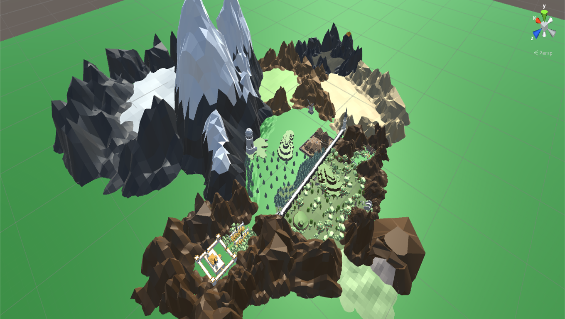Since the world is relatively large, and with many objects, I will break my world into many different scenes that the player switches to when they walk into the area. This will prevent too many objects with data and colliders taking up the computers’ resources when the player is not near them and it wouldn’t make any difference if they weren’t there.

**Hardware constraints**

This system is designed to be played of a windows system. Given the low quality of the graphics, I don’t think that there will be high strain of the hardware of the system.

**Software Constraints**

The user will have needed to have all of the relevant files downloaded to start the game.

**General Objectives**

1. **A finished game with all desired systems implemented**
2. **A game that can run well on a system**
3. **A database that stores the data of my users**

**Specific Objectives**

* A combat system using sword swing animations.
* A ranged combat system that involves arrow drop.
* A variety of enemy subclasses to the superclass.
* Melee enemies that have decent pathing towards the player.
* Ranged enemies that kite away from the player
* A variety of items to pick up.
* A decent trading/dialogue system with static NPCs (Non Player Characters)
* A save system that records player location, and the state of the world.
* An in game map that the player can hold to see where they are.
* A relational database that stores player info, level data and scores

**User Needs**

The user will have no need to have any computer science or Information technology knowledge. The system will need to be designed in such a way that somebody with minimal computer experience could operate effectively. Just in case the user is not aware of the default PC gaming keyboard and mouse controls, I would have to include a list of the key bindings and maybe offer a way to rebind them.

**Levels of Access**

The target audience will not have access to all areas of the program. The database will not be accessible to the player since it contains the log in data, and passwords of the users. The only admin user that will have access to this information will be me as the game designer. This is to prevent people stealing other people’s accounts and ruining their experience.

# References

[1] *https://ukie.org.uk/research*.

[2] *https://www.windowscentral.com/minecraft-dungeons*.

[3] https://www.rollingstone.com/culture/culture-features/skyrim-creator-on-why-well-have-to-wait-for-another-elder-scrolls-128377/

[4] https://wccftech.com/witcher-33-million-witcher-3-2017-pc/

[5] https://twinfinite.net/2018/07/10-indie-games-steam-leak/

[6] http://www.vgchartz.com/article/267678/rocket-league-sales-top-105-million-units/